Chameleon

In this project you will make a chameleon that changes colour to match its background.

You’ll use a webcam to take photos of different coloured objects, then use machine learning with those examples to train the chameleon to recognise colours.

The idea for this project came from Cassie Evans. You can see her version of it at

<https://codepen.io/cassie-codes/details/ZjErdL>



This project worksheet is licensed under a Creative Commons Attribution Non-Commercial Share-Alike License

http://creativecommons.org/licenses/by-nc-sa/4.0/

1. Go to <https://machinelearningforkids.co.uk/> in a web browser
2. Click on “**Get started**”
3. Click on “**Log In**” and type in your username and password  
   *If you don’t have a username, ask your teacher to create one for you.  
   If you can’t remember your password, ask your teacher to reset it for you.*
4. Click on “**Projects**” on the top menu bar
5. Click the **“+ Add a new project**” button.
6. Name your project “chameleon” and set it to learn how to recognise “**images**”. Click the “**Create**” button  
   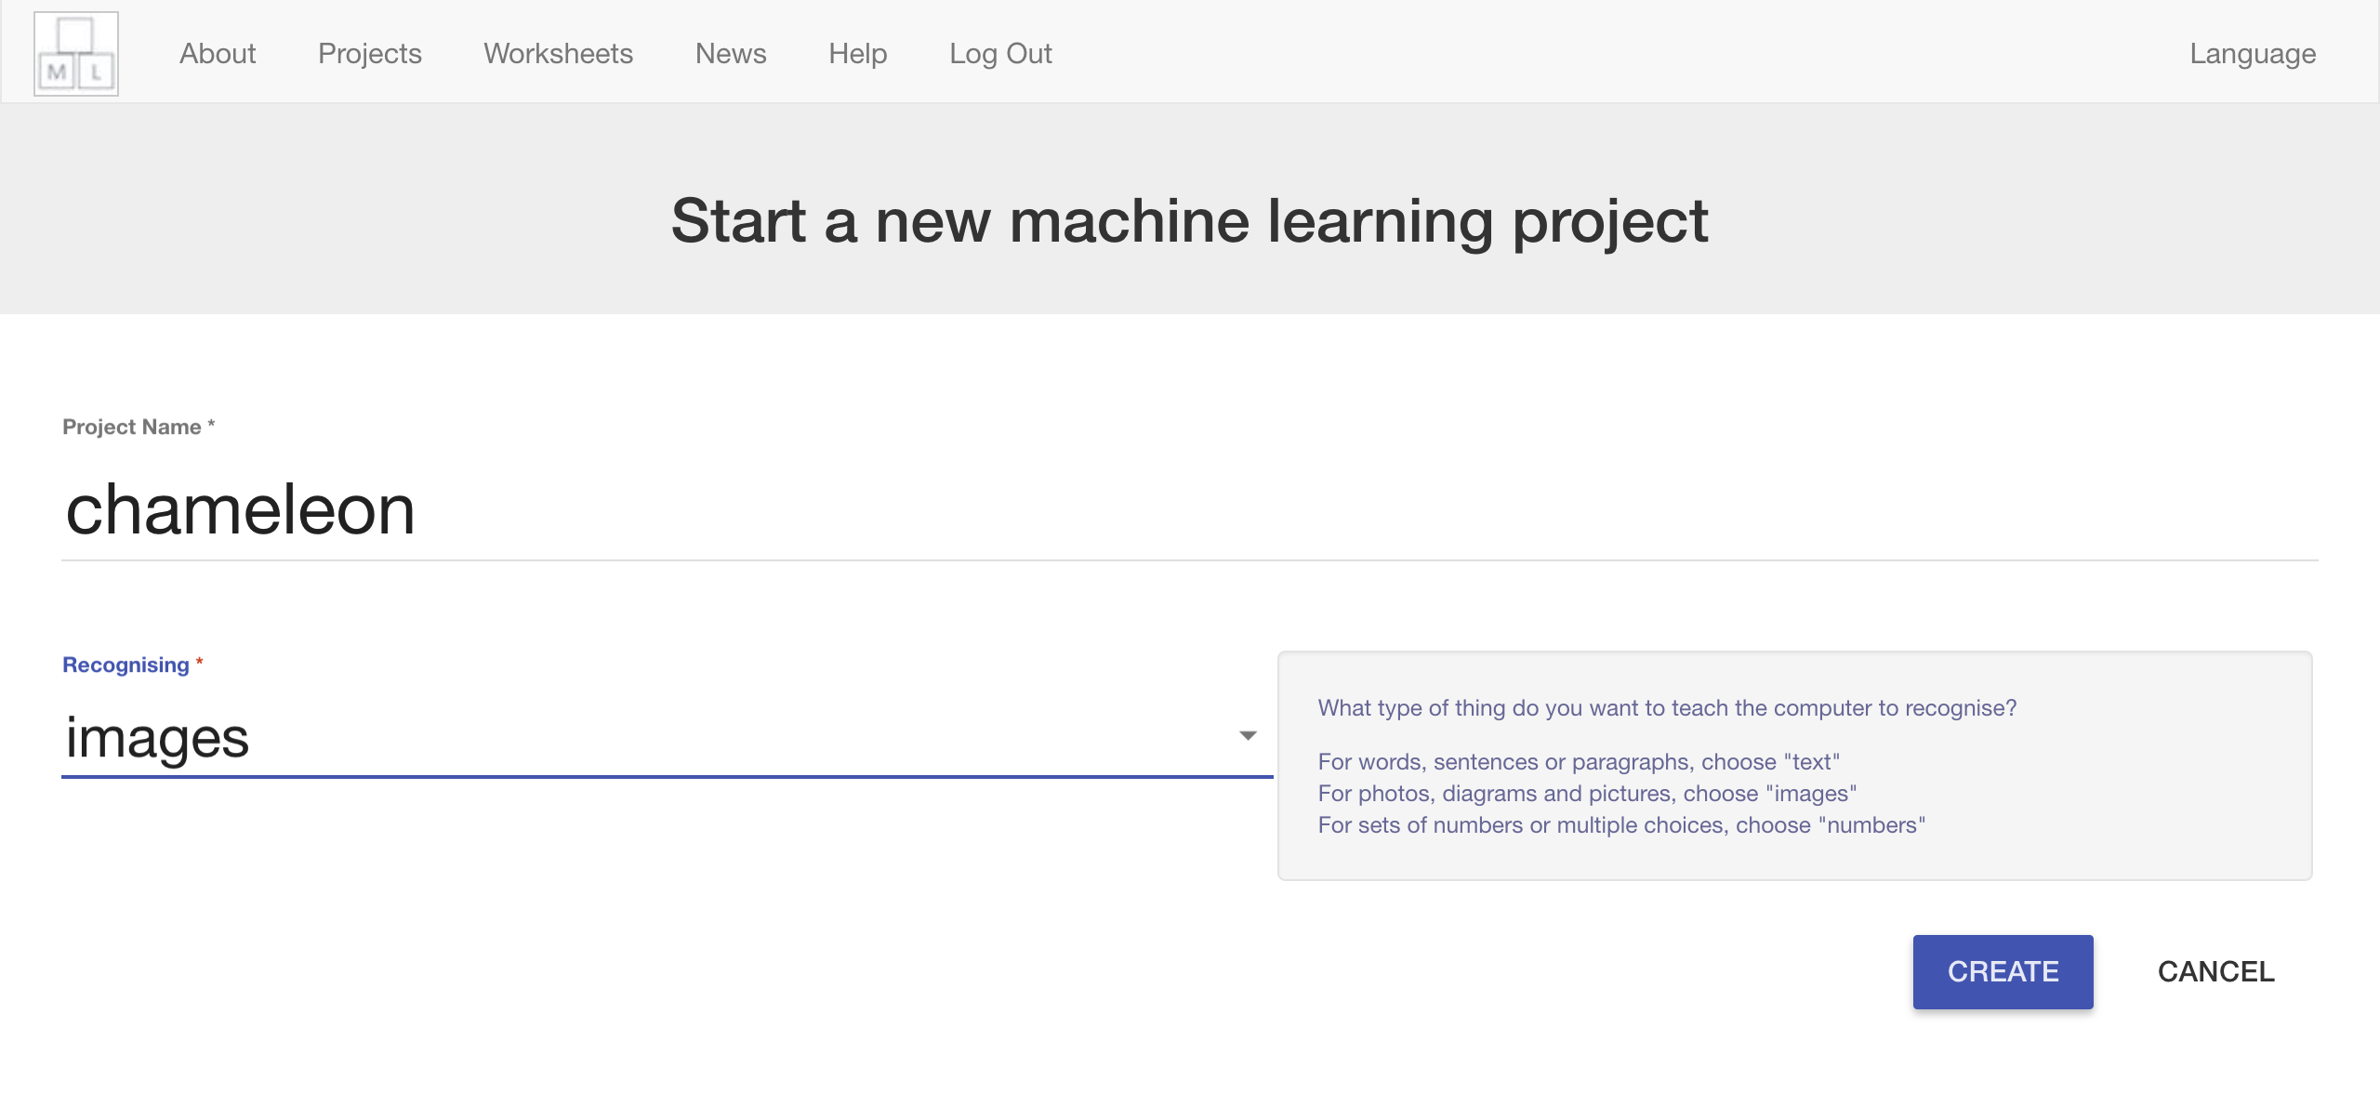
7. You should see “**chameleon**” in the list of your projects. Click on it.  
   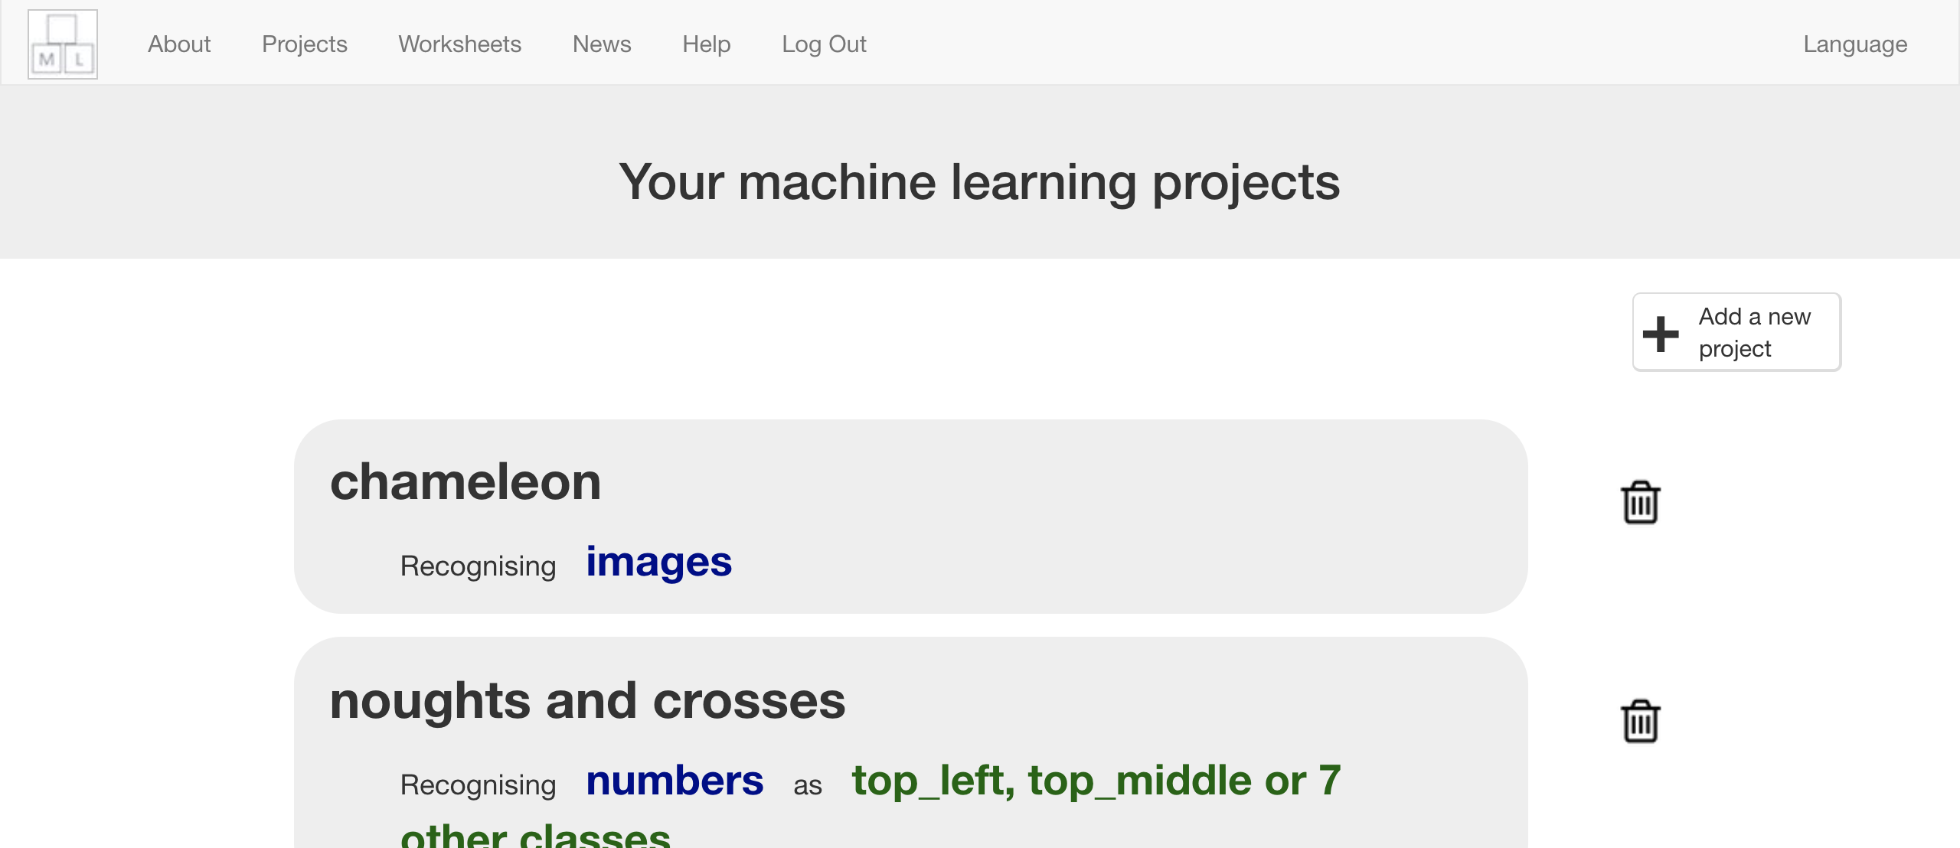
8. Click the **Train** button  
   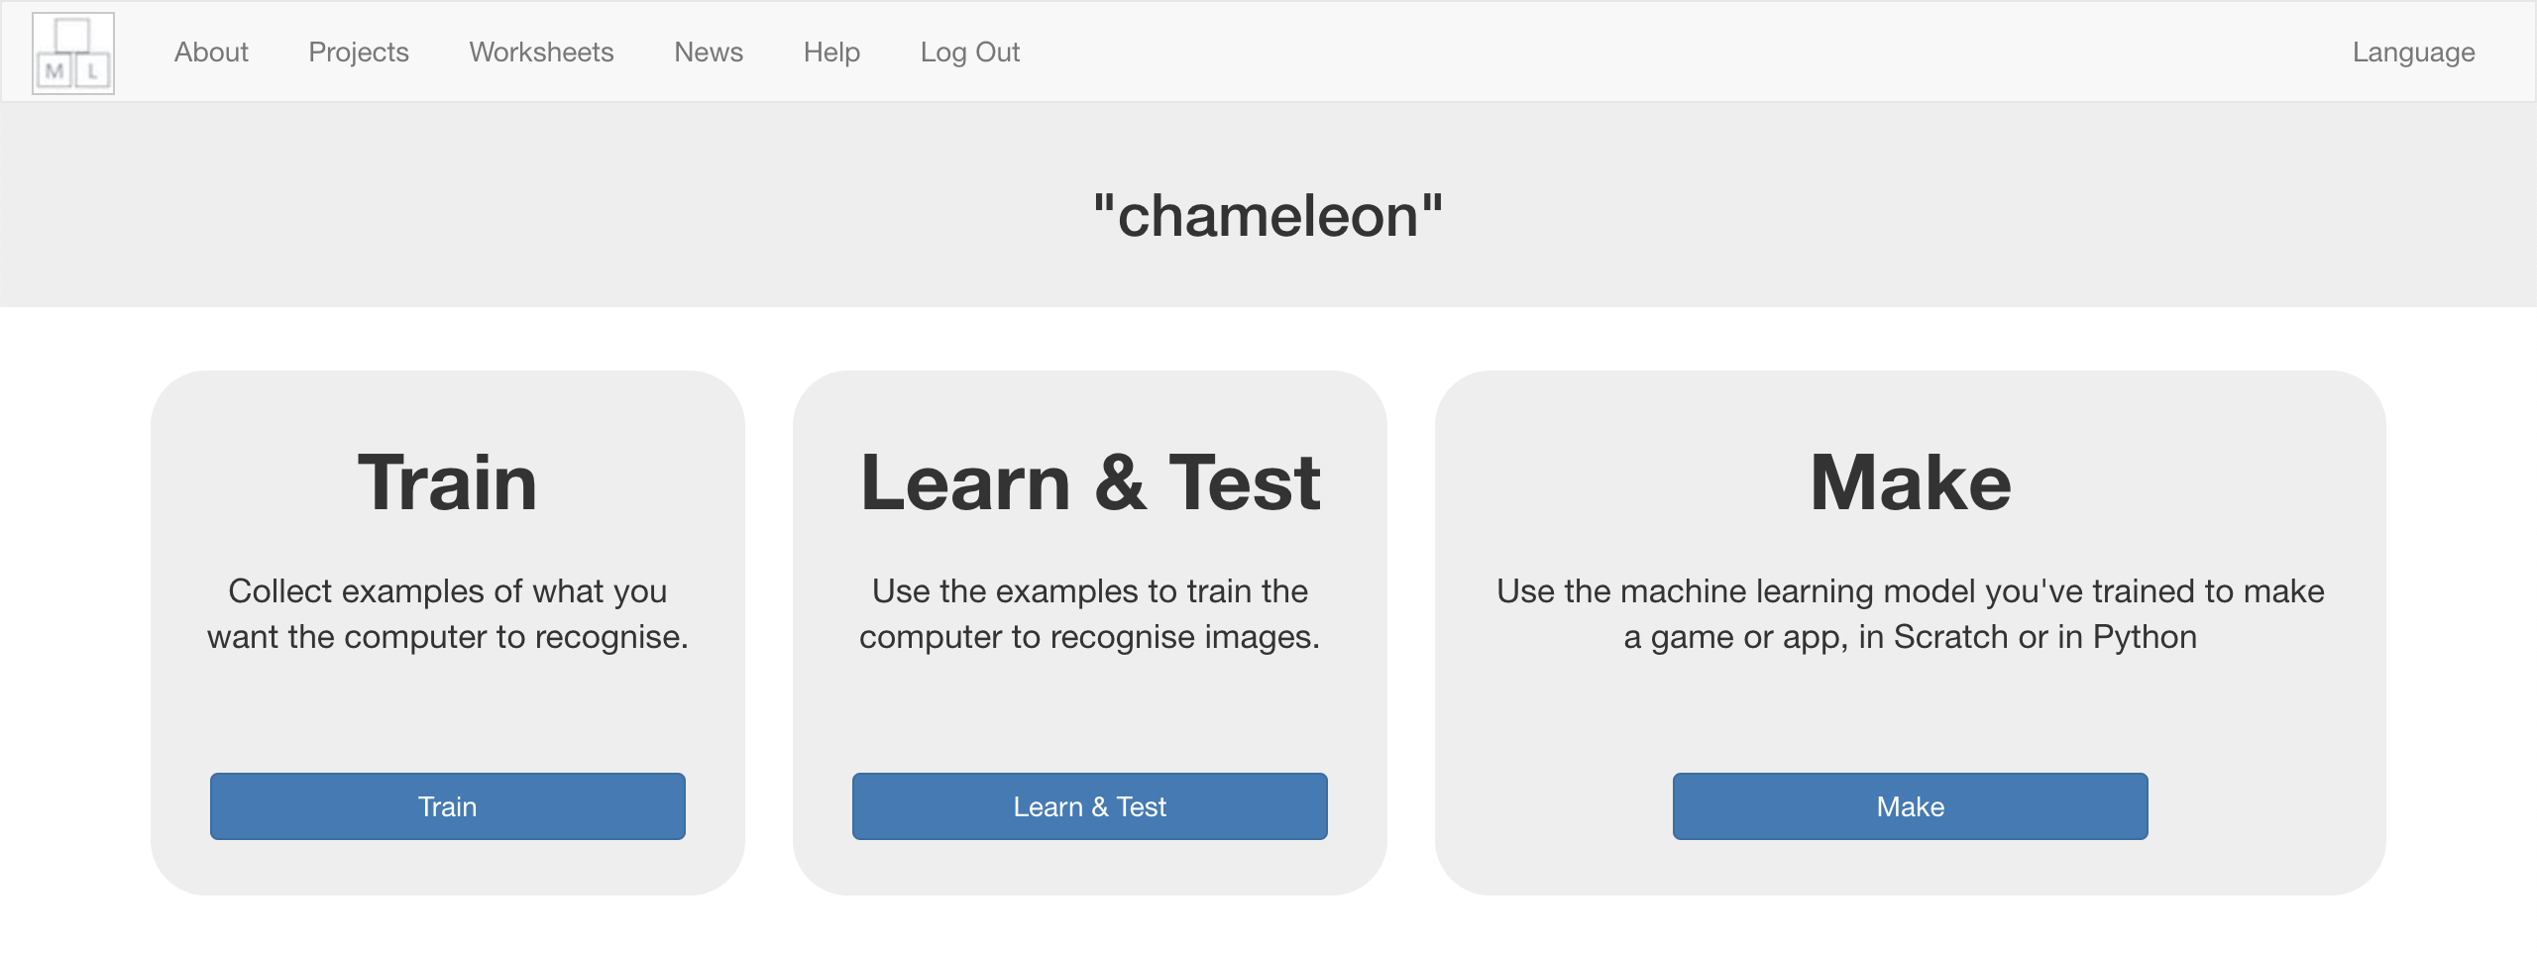
9. Choose three colours  
   *Choose colours that you’ll easily be able to find. For the rest of this worksheet, I’ll be using red, green, and blue.*
10. Click “**+ Add new label**”  
    
11. Type in the name of your first colour, and press **Add**
12. Do that again for your other two colours  
    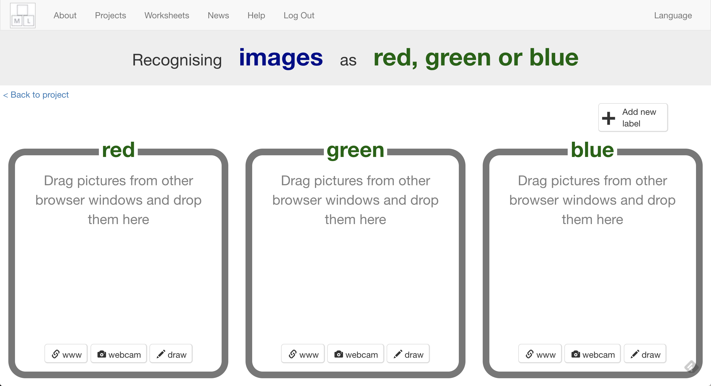
13. Click on the webcam button in your first colour bucket  
    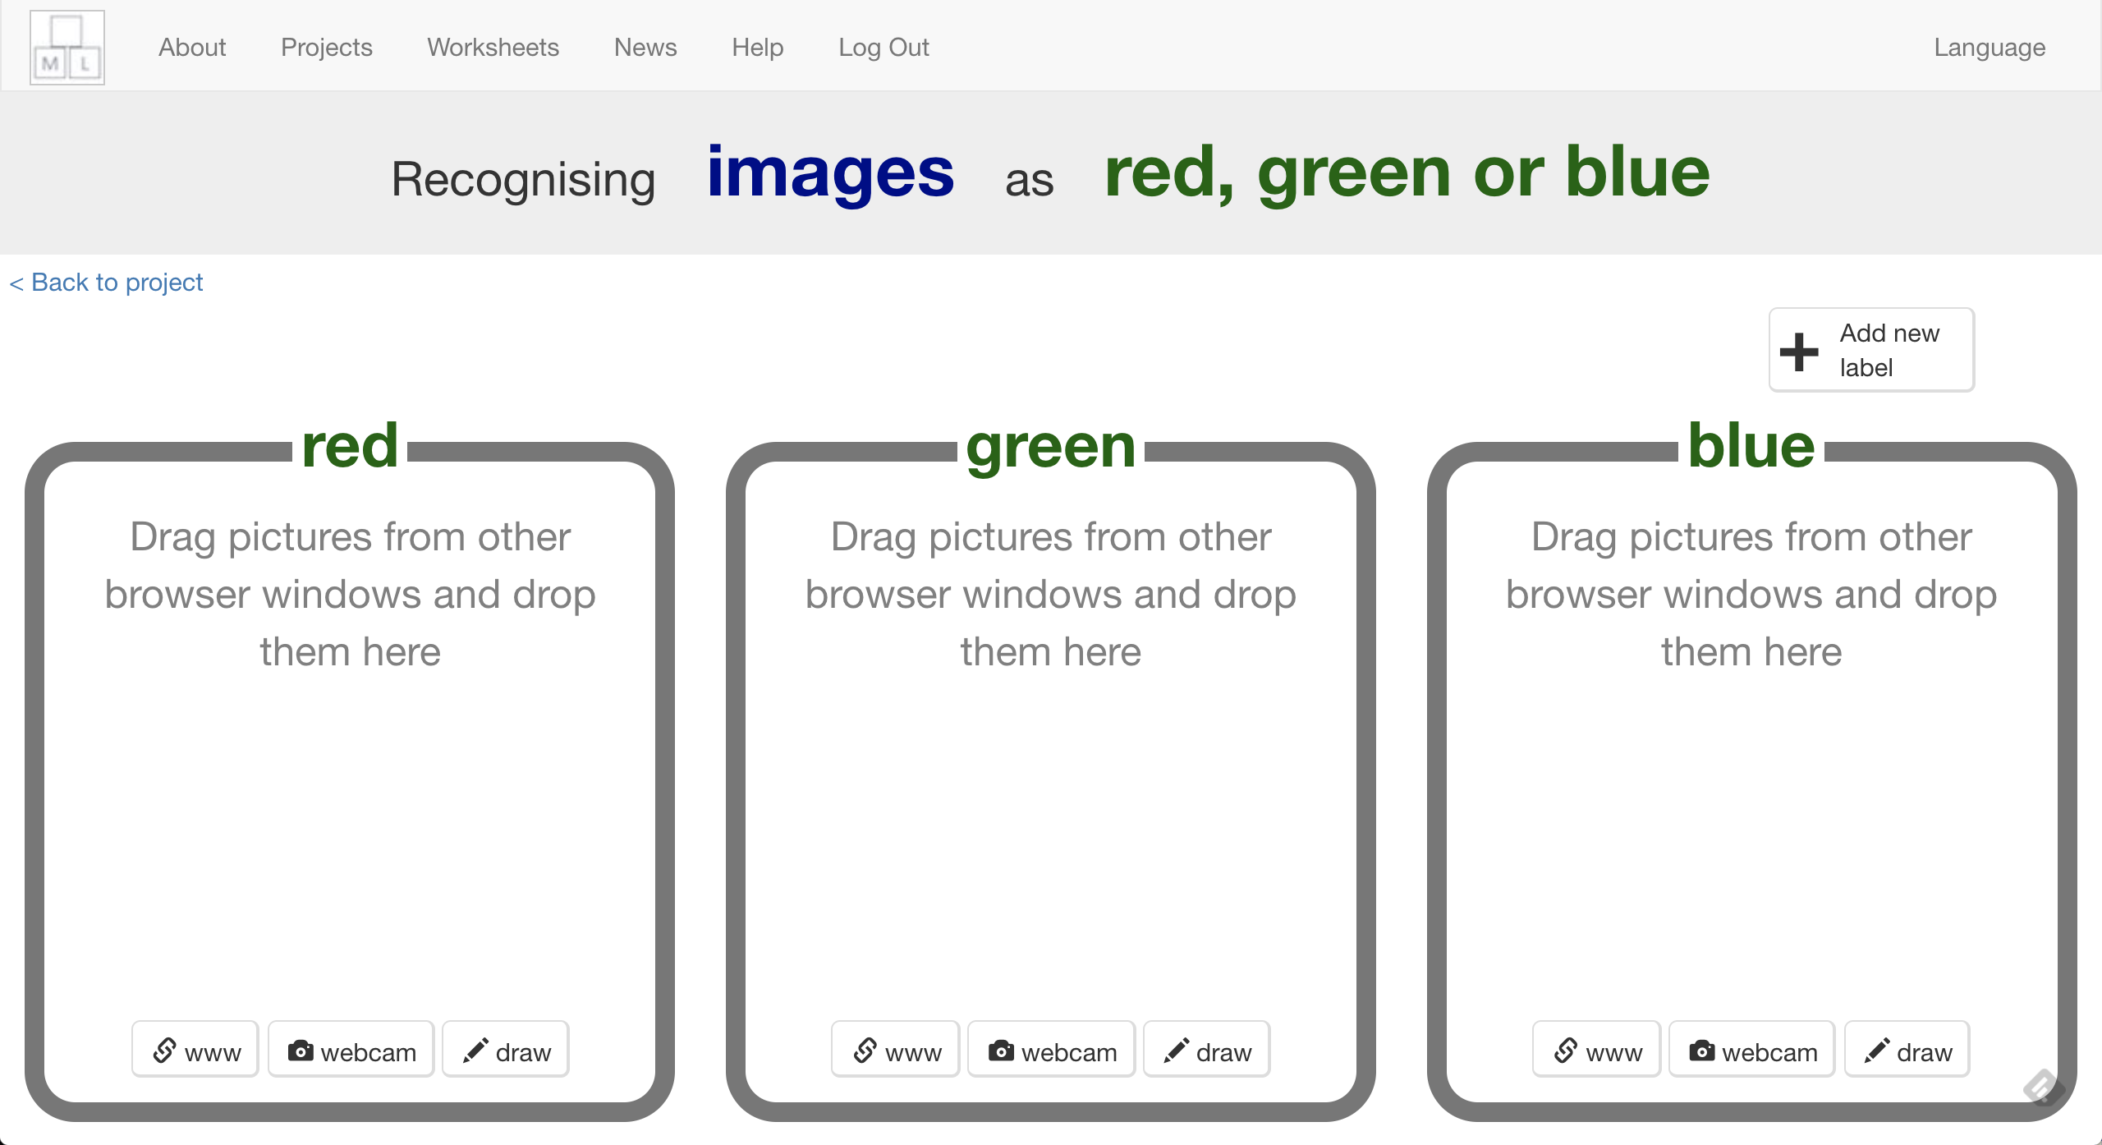
14. Take a photo of something that is that colour   
    *Try to fill a lot of the picture*
15. Repeat until you’ve got **ten examples** in each colour  
    *Try to find different objects for each colour. If that’s not possible, take more than one picture of things from different angles or upside-down*
16. Click “**< Back to project**”
17. Click **Learn & Test**
18. Click the “**Train new machine learning model**” button  
    *It might take a few minutes for the model to train.*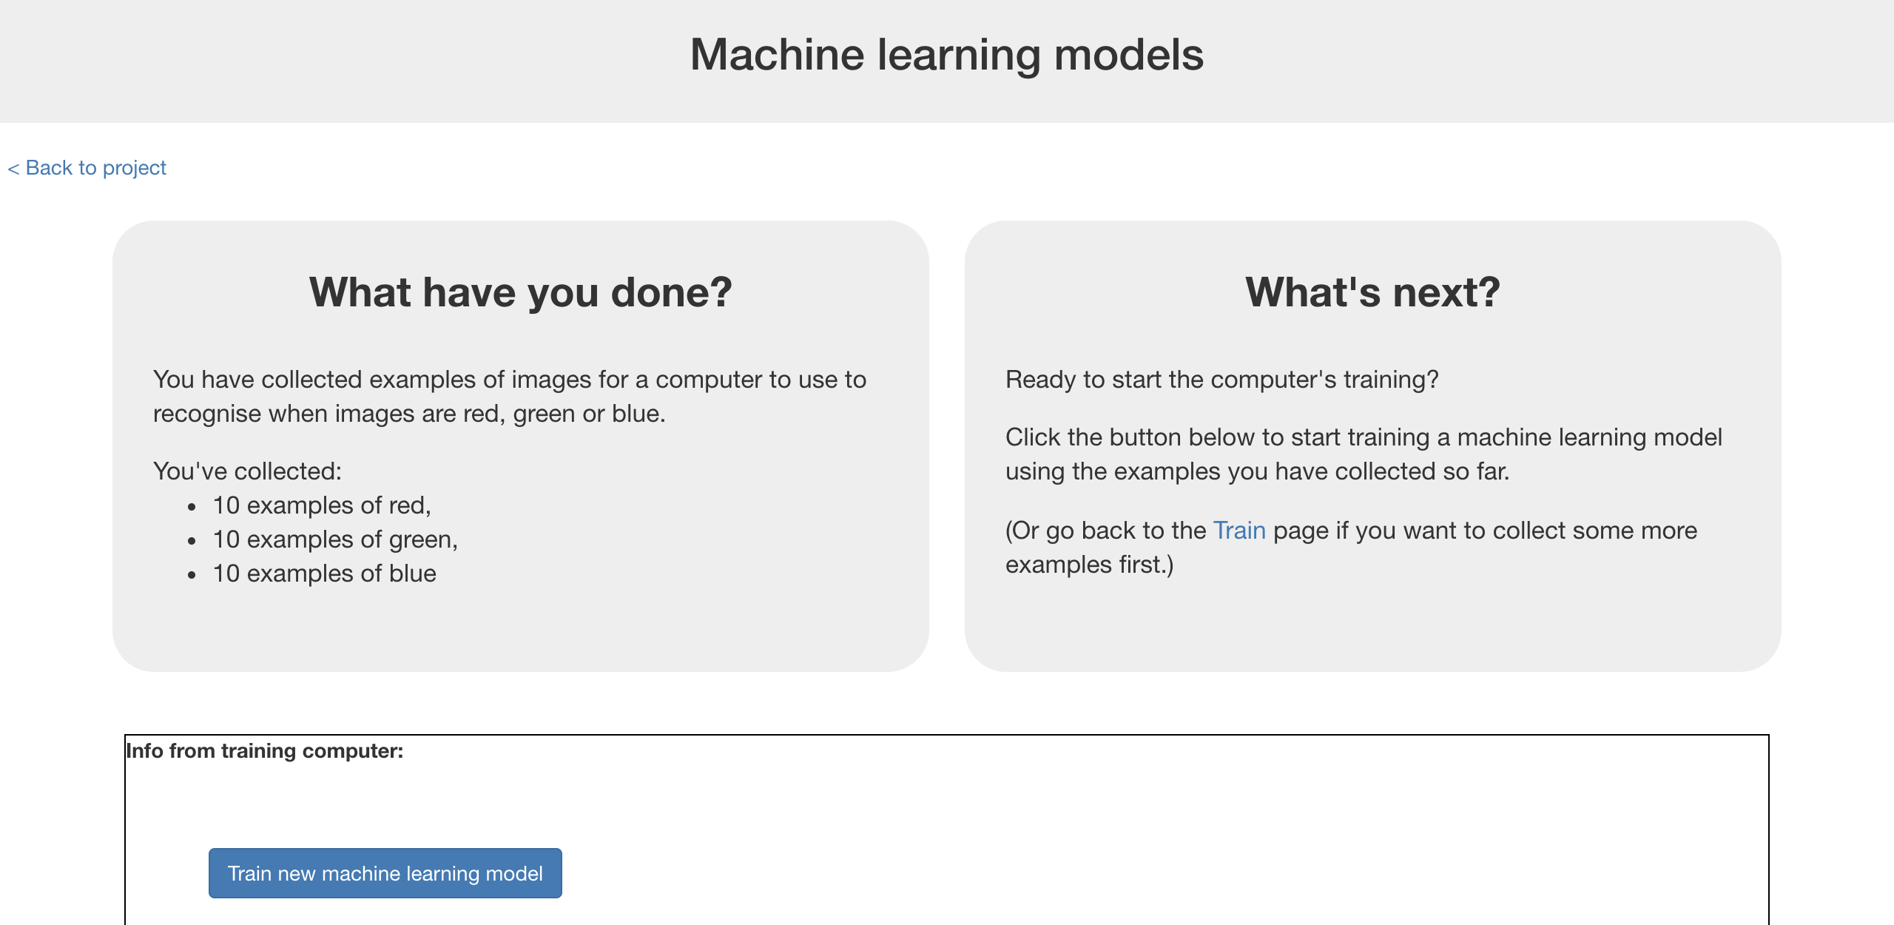

**What have you done so far?**

You’ve started to train a computer to recognise colour of a picture. You are doing it by taking example photos. These examples are being used to train a machine learning “model”.

This is called “supervised learning” because of the way you are supervising the computer’s training.

The computer will learn from patterns in the colours from each of the photos you’ve given it. These will be used to recognise new photos.

1. Click “**< Back to project**”
2. Click the “**Make**” button
3. Click “**Scratch**”
4. Click on **Open in Scratch**  
   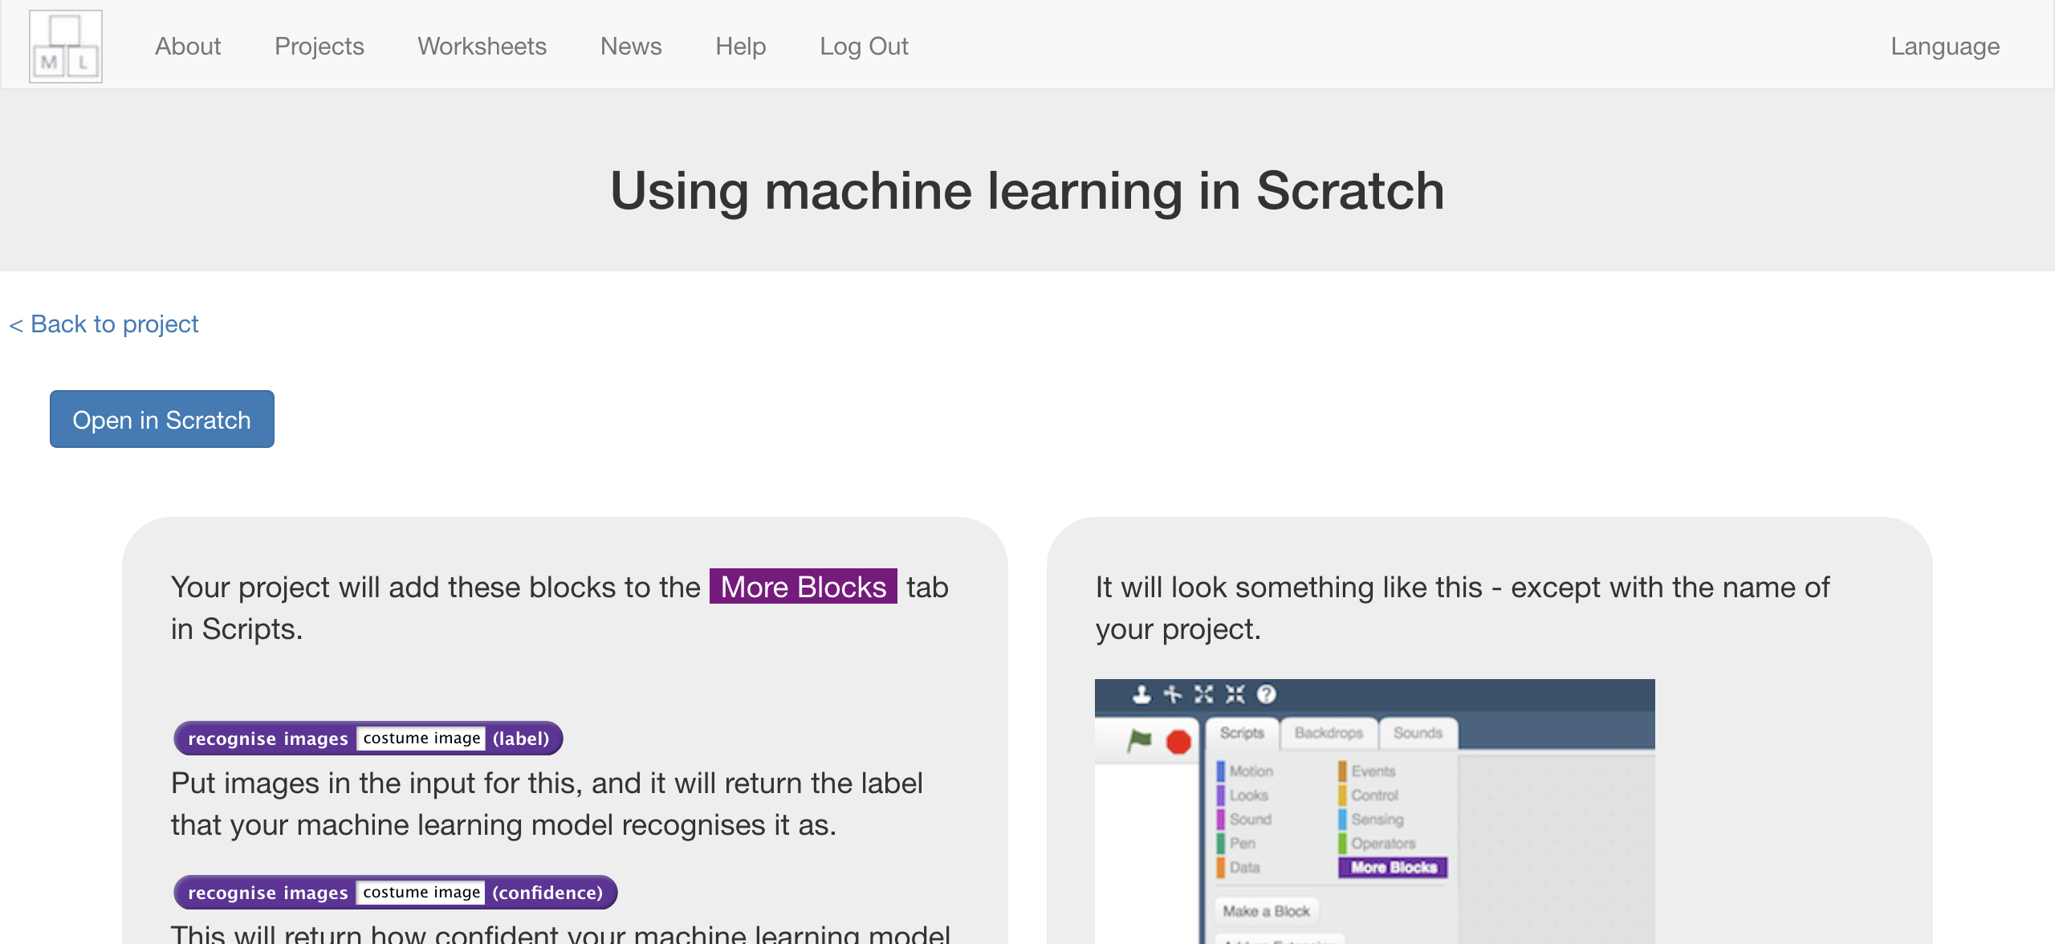
5. You should see blocks in “**More blocks**” from your project.  
   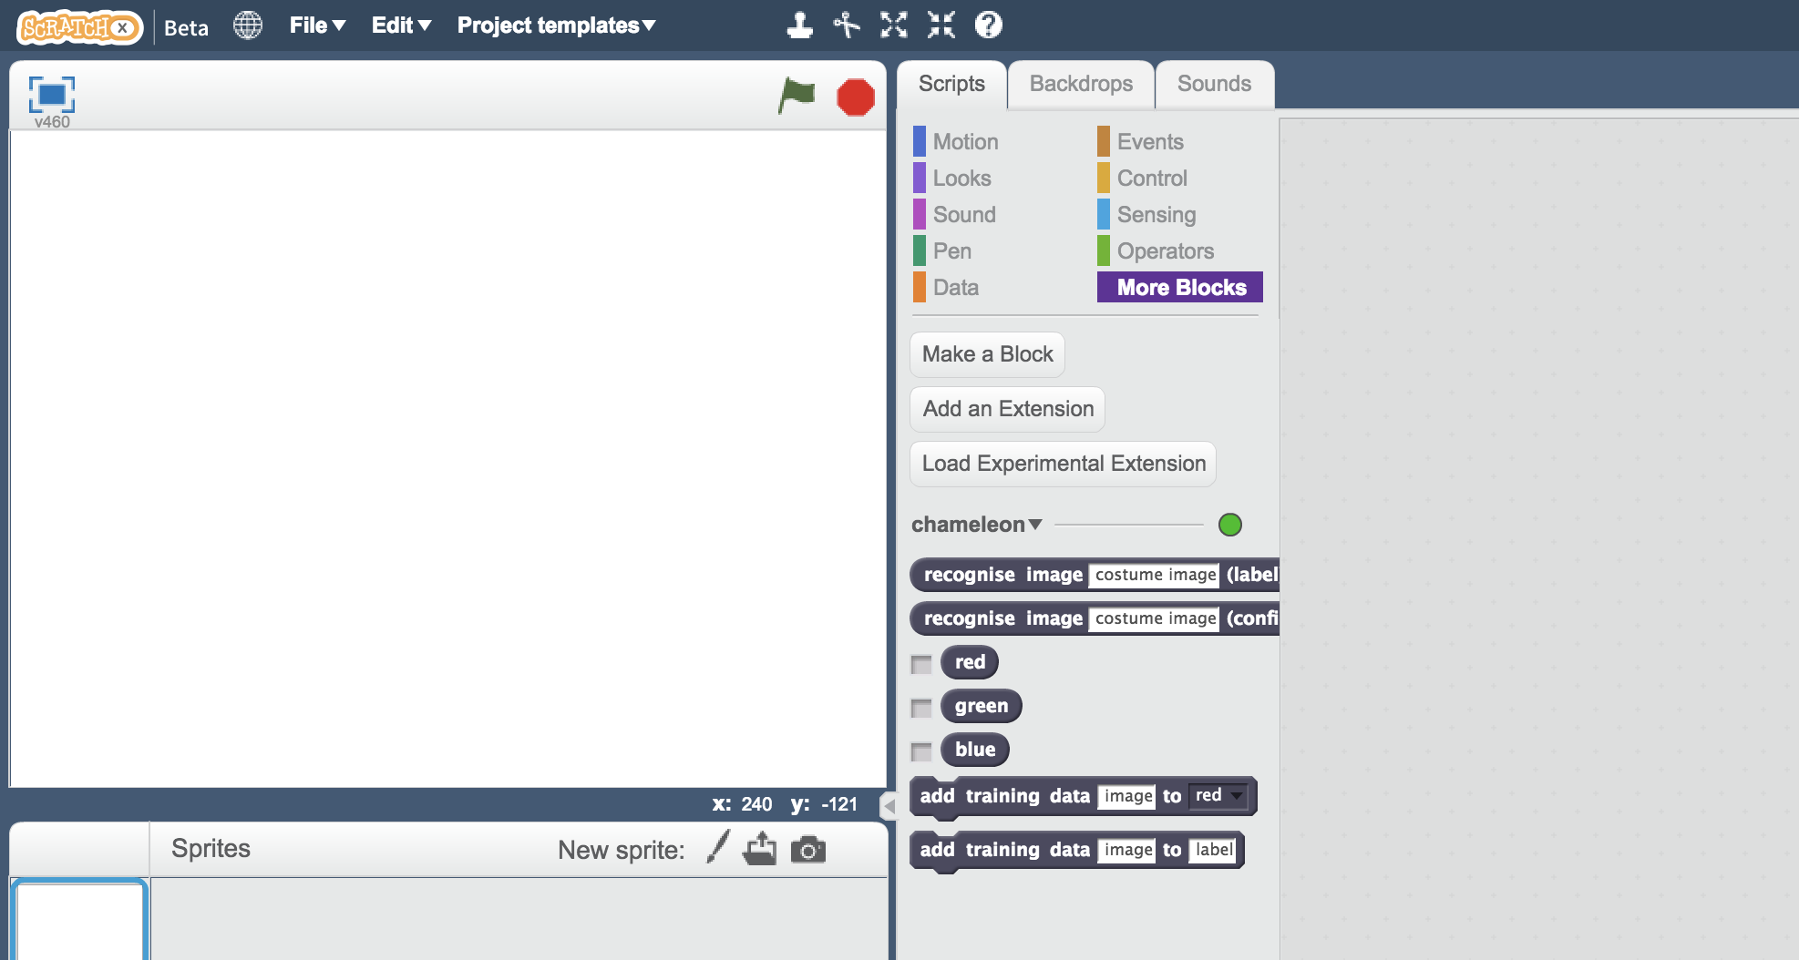
6. Open the project template  
   *Click on* ***Project templates*** *->* ***Chameleon***

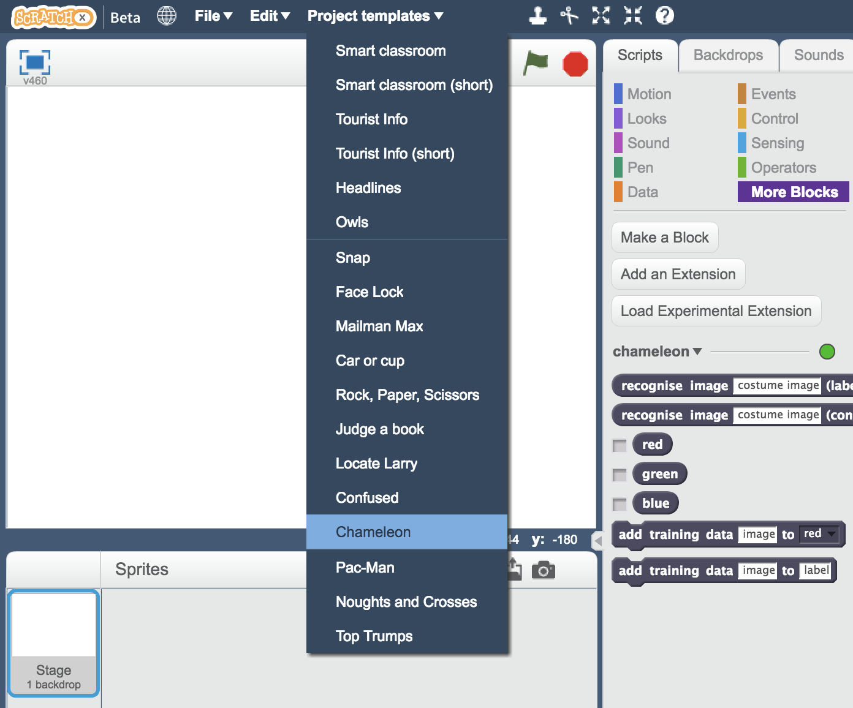

1. Click on the **Costumes** tab  
   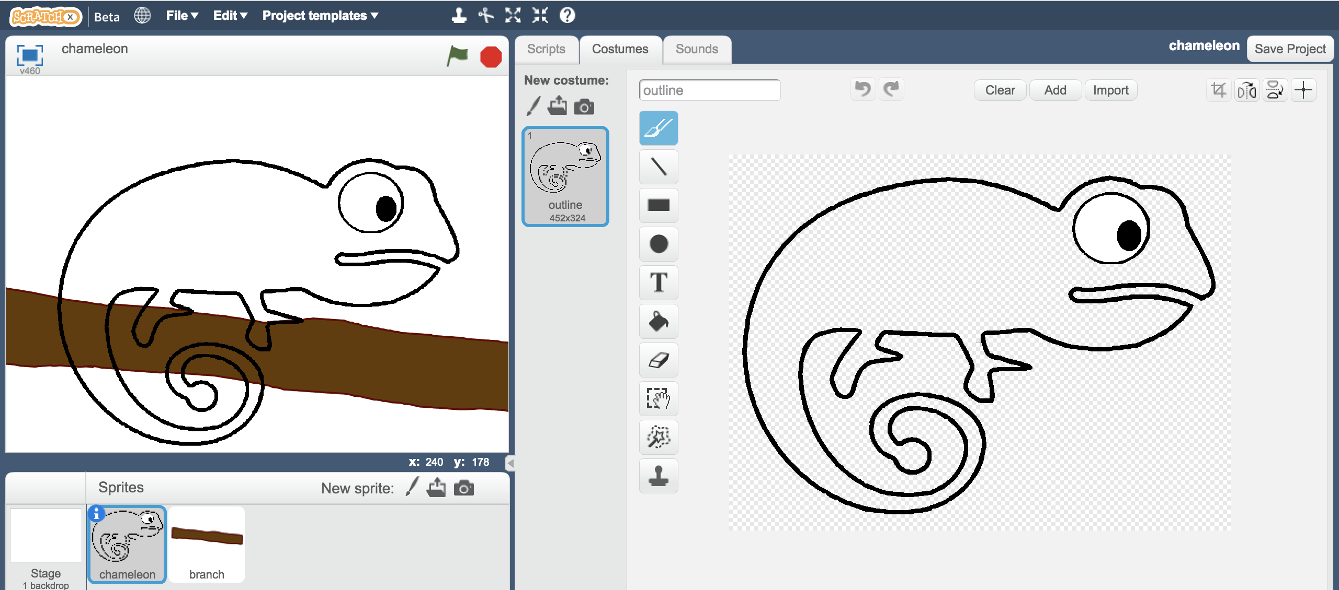
2. Right-click on the “**outline**” costume, and click “**duplicate**”  
   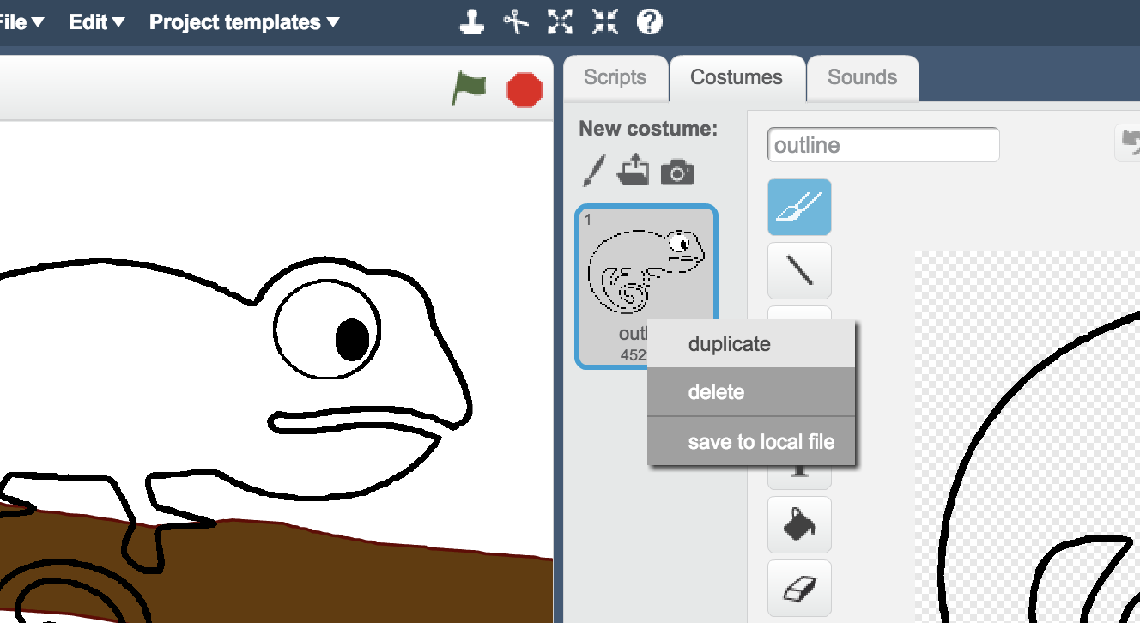
3. Name the duplicate costume the name of the first of your colours  
   *It’s very important that the name matches exactly, or your script won’t work.*  
   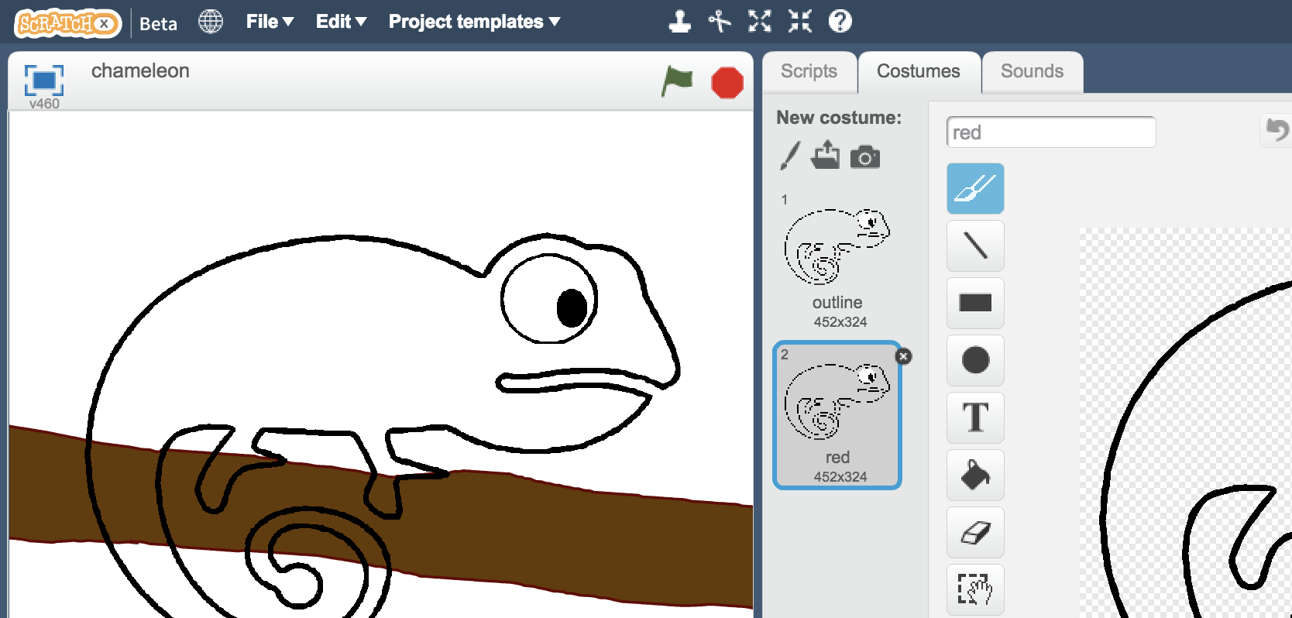
4. Use the **paint fill tool** to colour in the chameleon costume  
   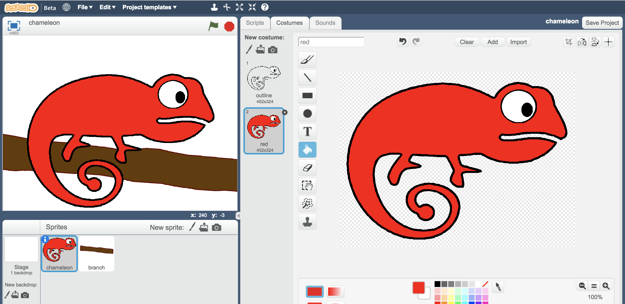
5. Repeat. Duplicate the outline costume again, name it after the second of your colours, and colour it in  
   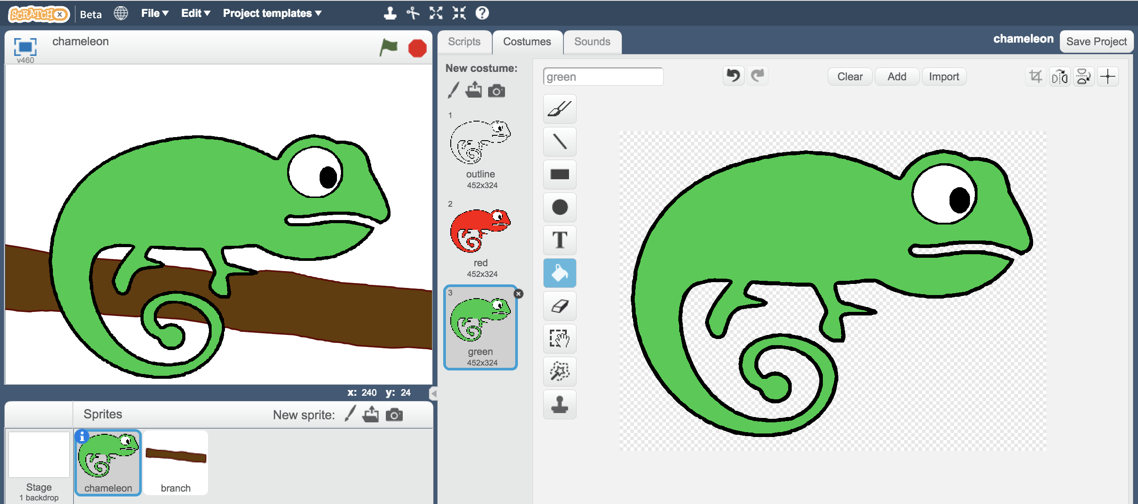
6. Repeat again to get the third colour costume  
   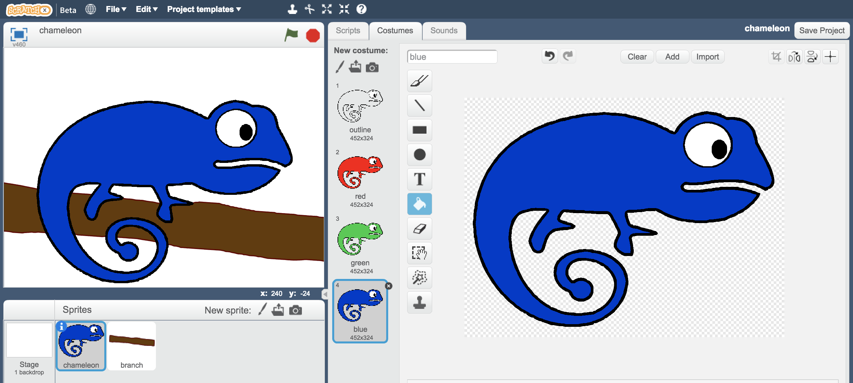
7. Click on the **Stage**  
   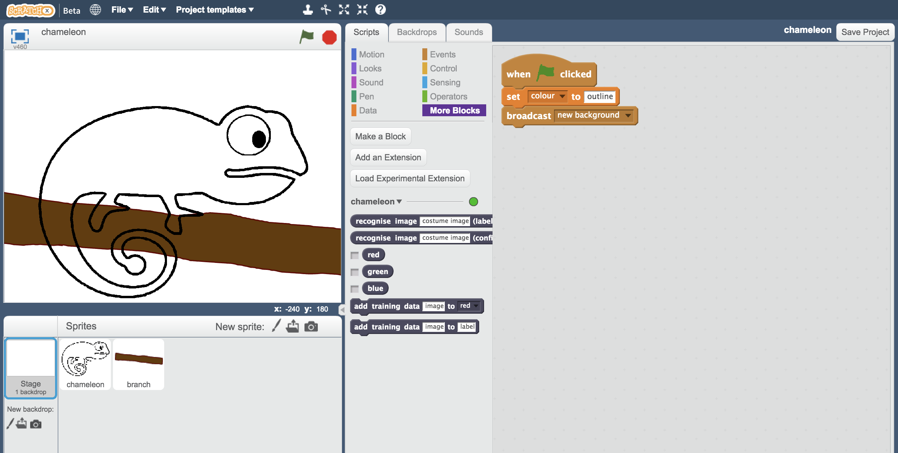
8. Change the script (that is there already) so it matches this   
   *This will recognise the colour of the background, then send an event to let the chameleon know what colour it should change to.*  
   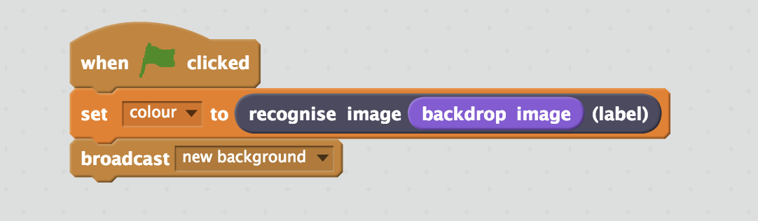
9. Save your project  
   *Click* ***File*** *->* ***Save Project***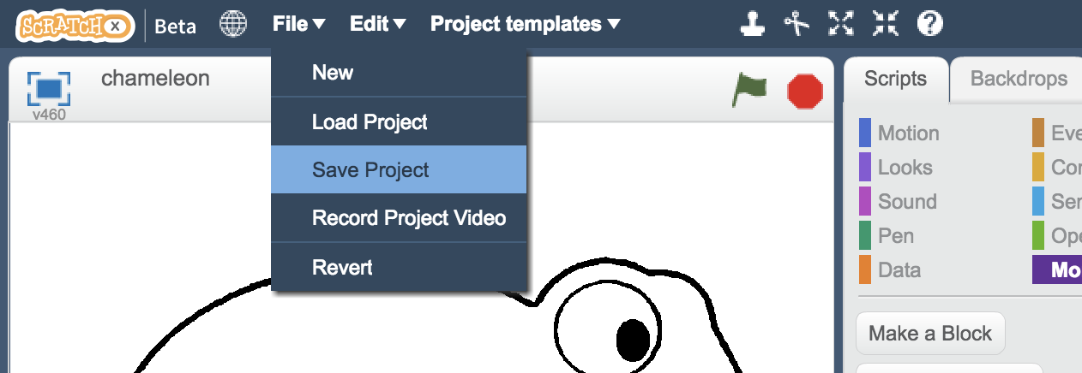
10. Click on the **Backdrops** tab  
    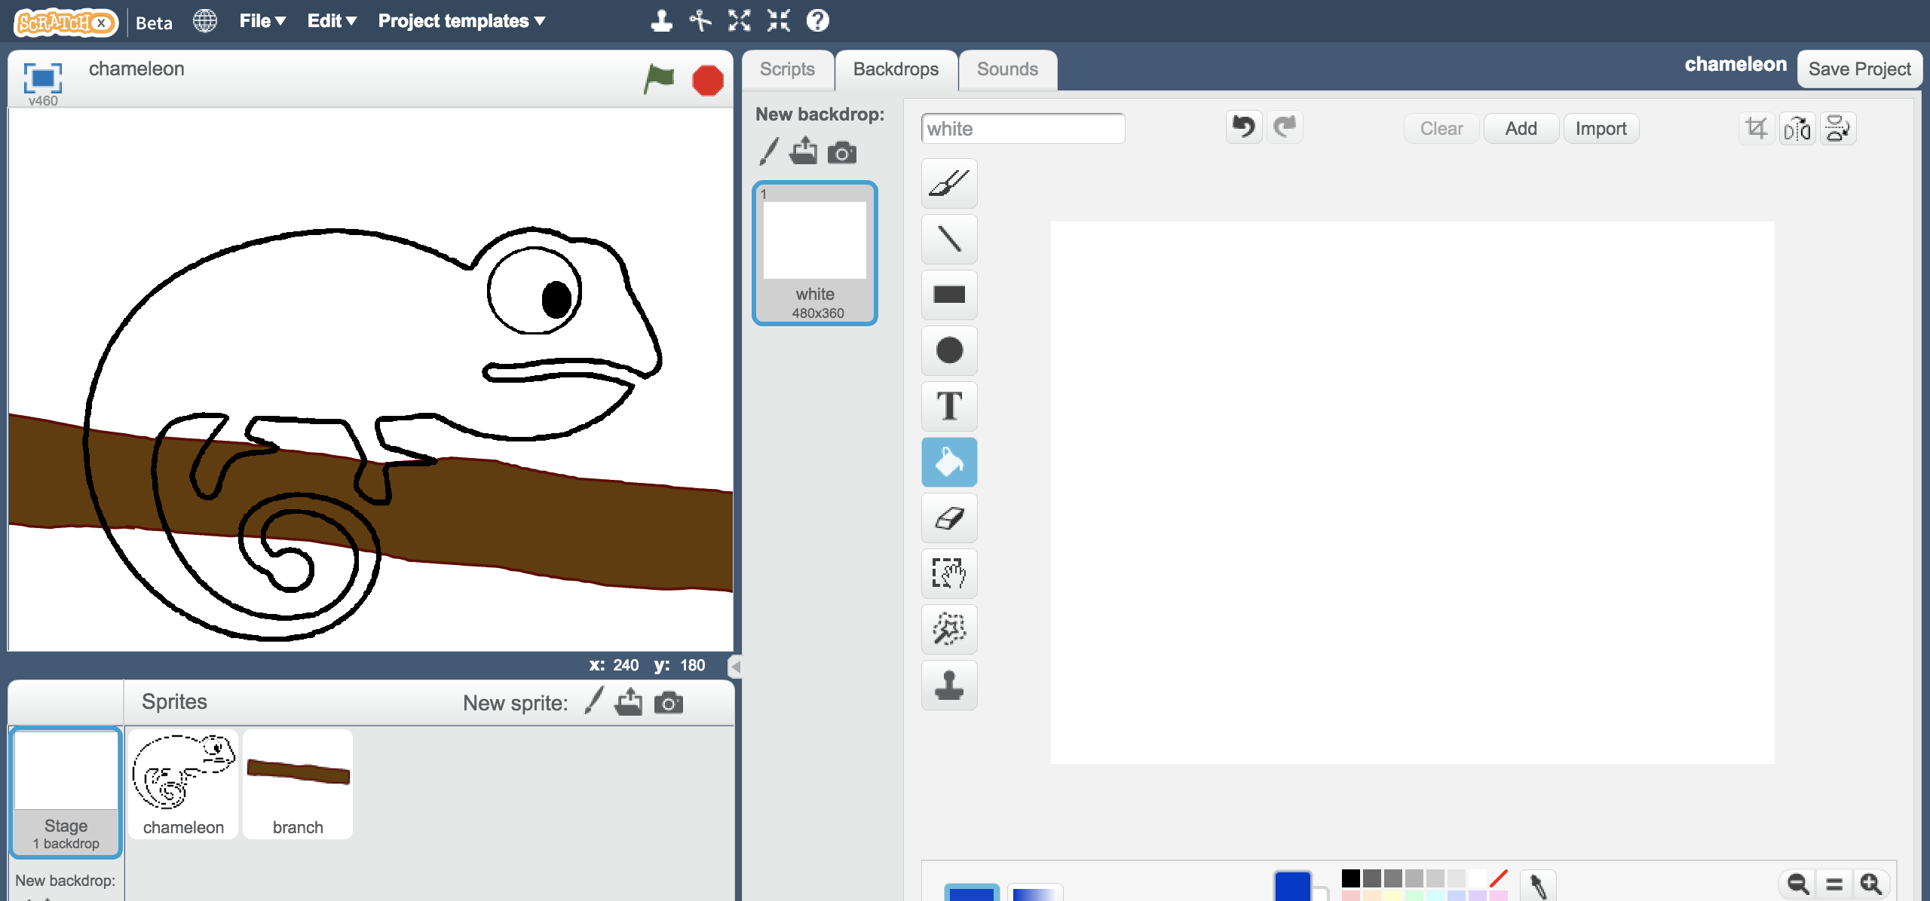
11. Click the **New backdrop from camera** button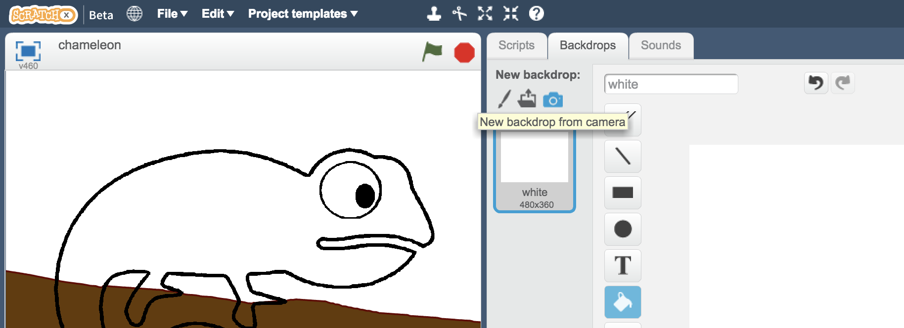
12. Take a photo to give the chameleon a new background  
    *Try to take a photo of something different that you didn’t use to train your machine learning model.*  
    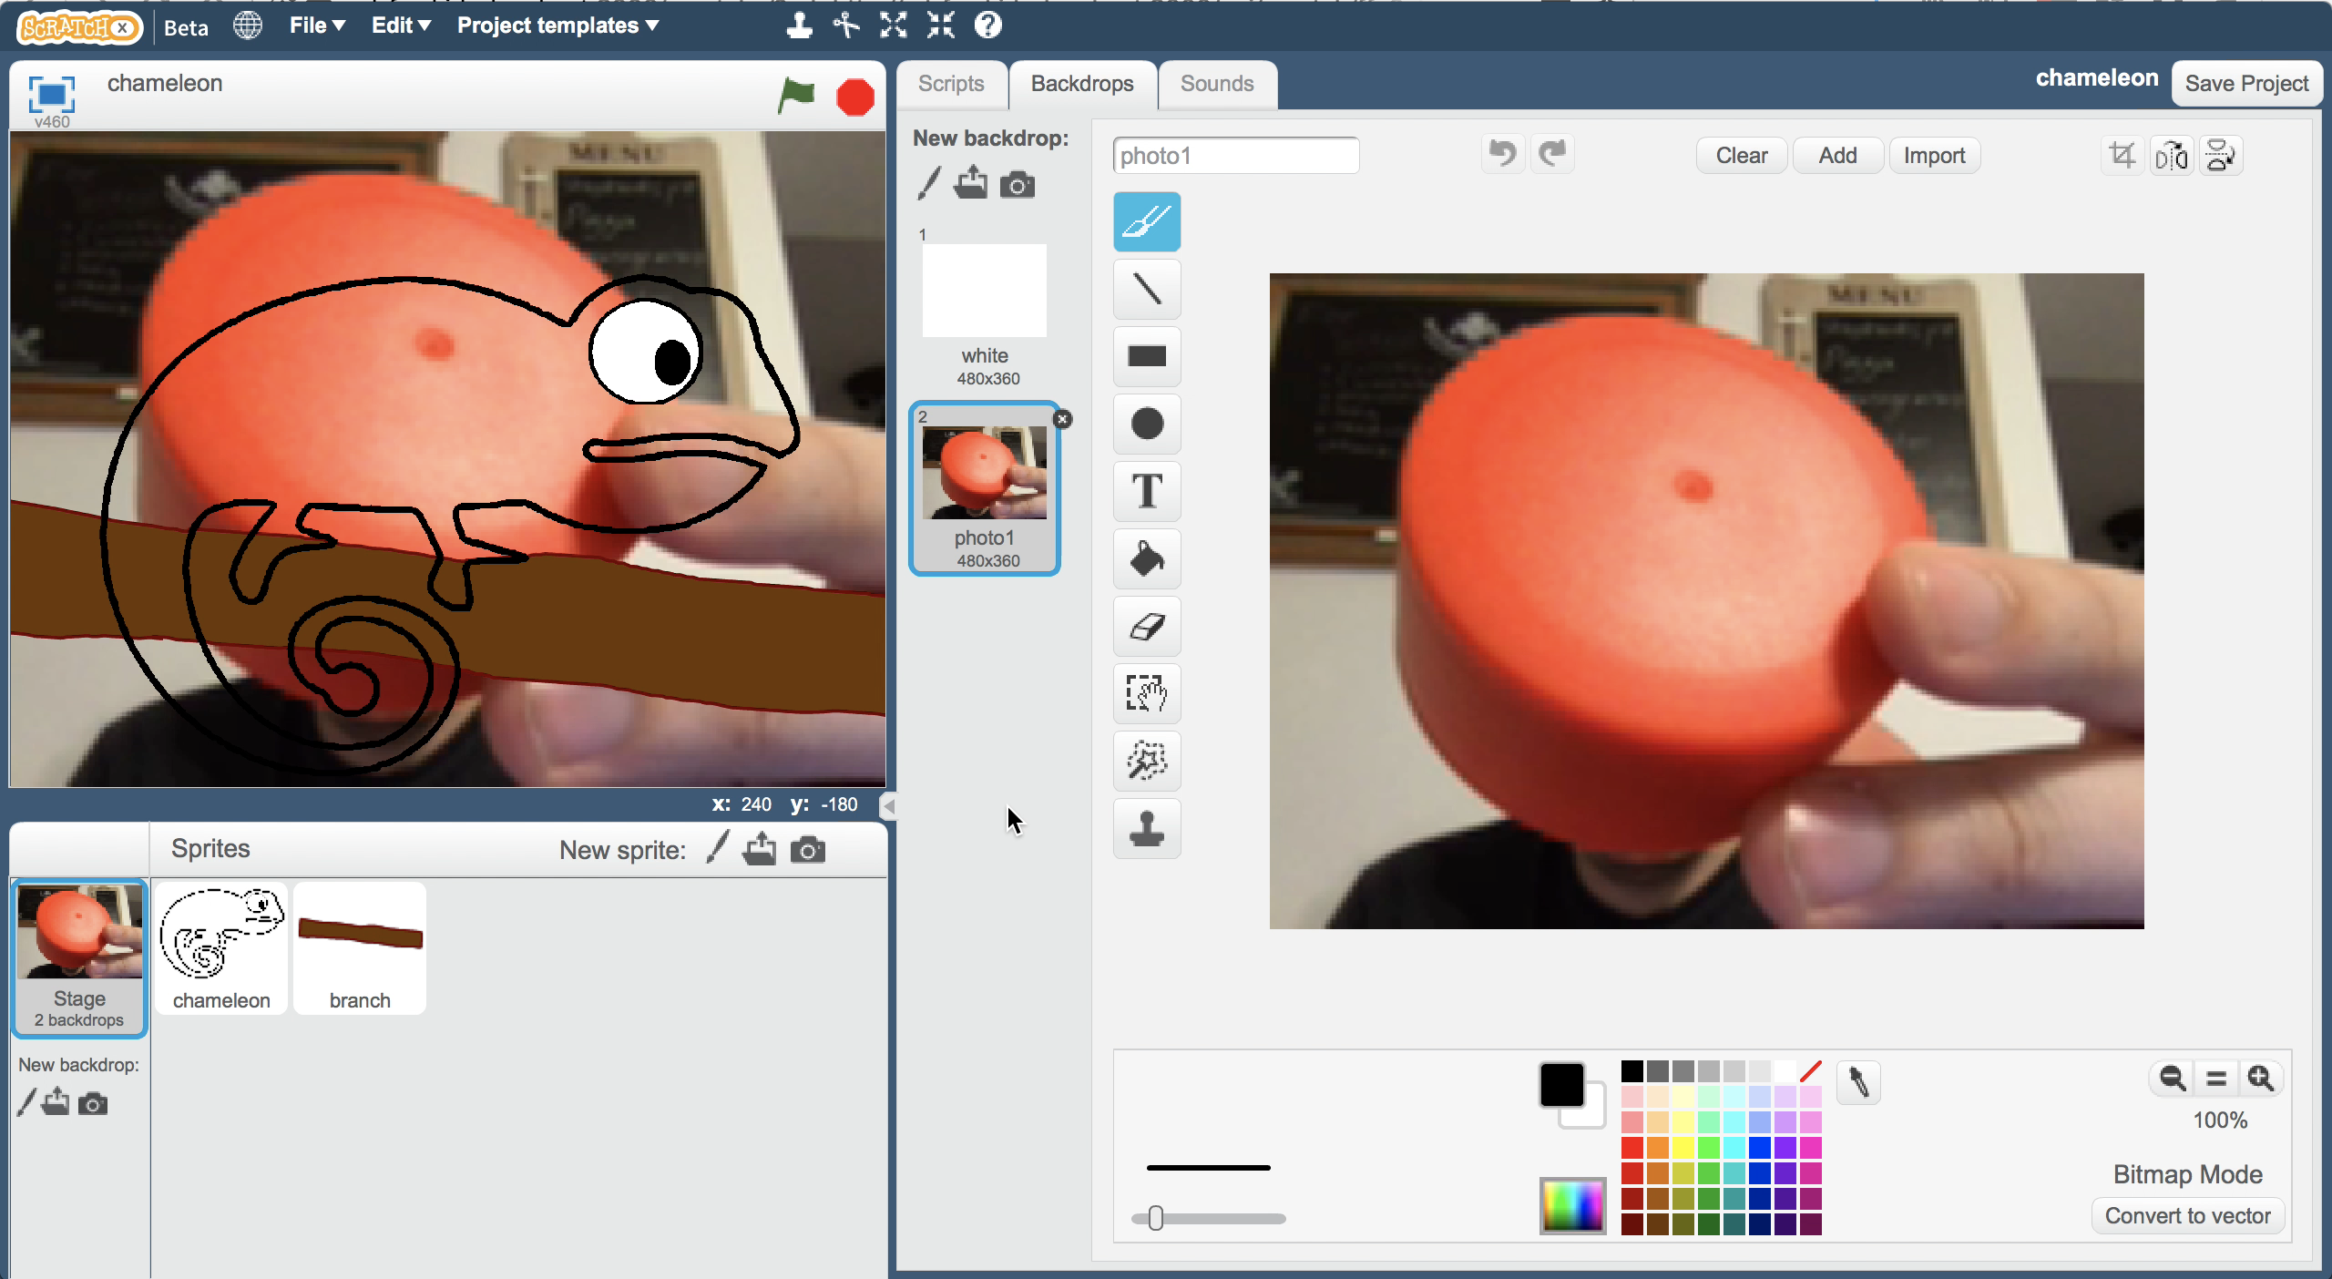
13. Click on the **Green Flag***The chameleon should change to the colour of the object in the background.  
    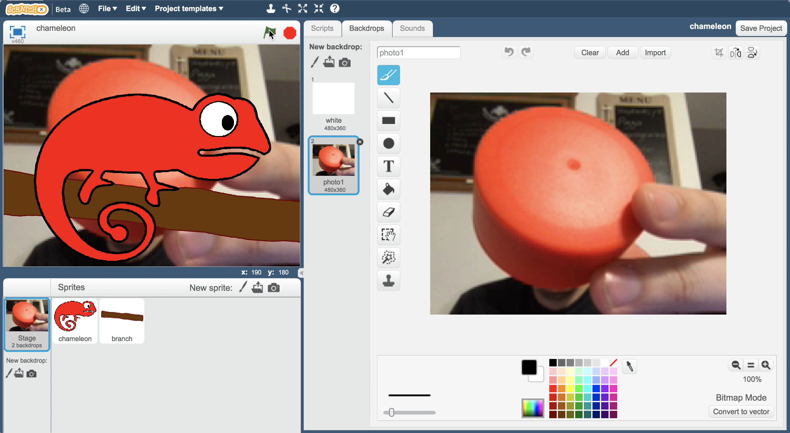*

**What have you done?**

You’ve created a chameleon in Scratch that uses machine learning to recognise the colour of the backdrop, and uses that to switch the costume to match.

The more examples you give it, the better it should get at recognising colours correctly.

**Ideas and Extensions**

Now that you’ve finished, why not give one of these ideas a try?

Or come up with one of your own?

**Style your chameleon**

You don’t have to have a plain chameleon. Why not try designing your own camouflage styles?  
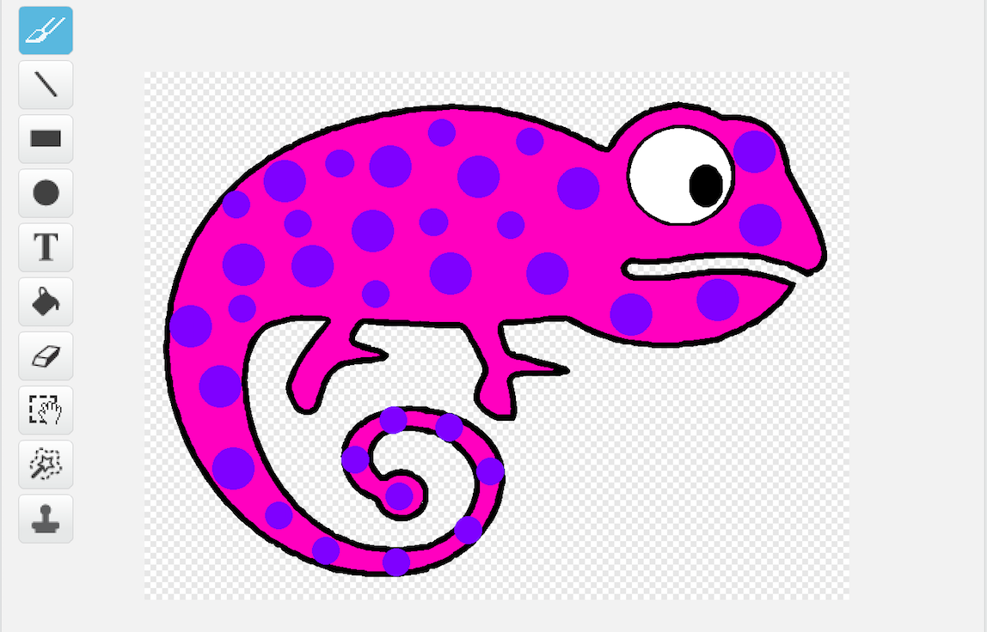

**Cheeky chameleon**

Try adding a fourth bucket to your training data, with ten photos of you sticking your tongue out.   
Add another costume of the chameleon and draw on a tongue sticking out.

When the machine learning model recognises you sticking your tongue out, you can switch to this costume, so your chameleon sticks out its tongue too!